CVIČENÍ – GOING TO
- What ARE they GOING TO DO in the afternoon? Napiš, co budou lidé na obrázcích dělat odpoledne (celou větou)?
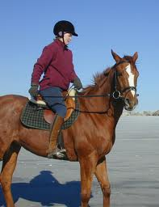
________________________________________________________________________________________________________________________________________________________________________________________________________________________________________________________________________________________________________________________________________________________________________________________
- Doplň kladné tvary s použitím budoucího času GOING TO a věty přelož:
I _____________________________ there. (stay) ___________________________________
He ____________________________ a party. (have) ________________________________
They __________________________ us next week. (visit) ____________________________
She ______________________________ an email.(send)______________________________
We ________________________________ a good day.(have) __________________________

- Doplň záporné věty s použitím budoucího času GOING TO:
I ____________________________ (work) in the evening.
Our kids _________________________ (eat) in fast food because it isn´t healthy.
You ____________________________ (watch) a Marvel film tonight.
Henry ____________________________ (drive) a motorbike.
Czech sportsmen ____________________________ (win) the World Cup.
She ____________________________ (fly) to Greece this year.

- Doplň otázky s použitím GOING TO a ODPOVĚZ na ně:
___________ you ___________________________a lot of English? (speak) ___________
___________ your teacher __________________________ golf? (play) ___________
___________ we ___________________________in a lake? (swim) ___________
___________ you___________________________ in a hotel? (sleep) ___________
___________ she ___________________________to a supermarket today? (go) ___________
___________ your family______________________ fish and chips for dinner? (eat) ___________
___________ your dad ___________________________an umbrella outside? (take) ___________

